10/21/2021

Mobile Application Development

Lab1

Safdar Hussain, BSCS-VII-A

CMS: 023-18-0059

Contents

Task-1 2

Task-2: 4

Task-3 8

# Task-1

Code Screenshot

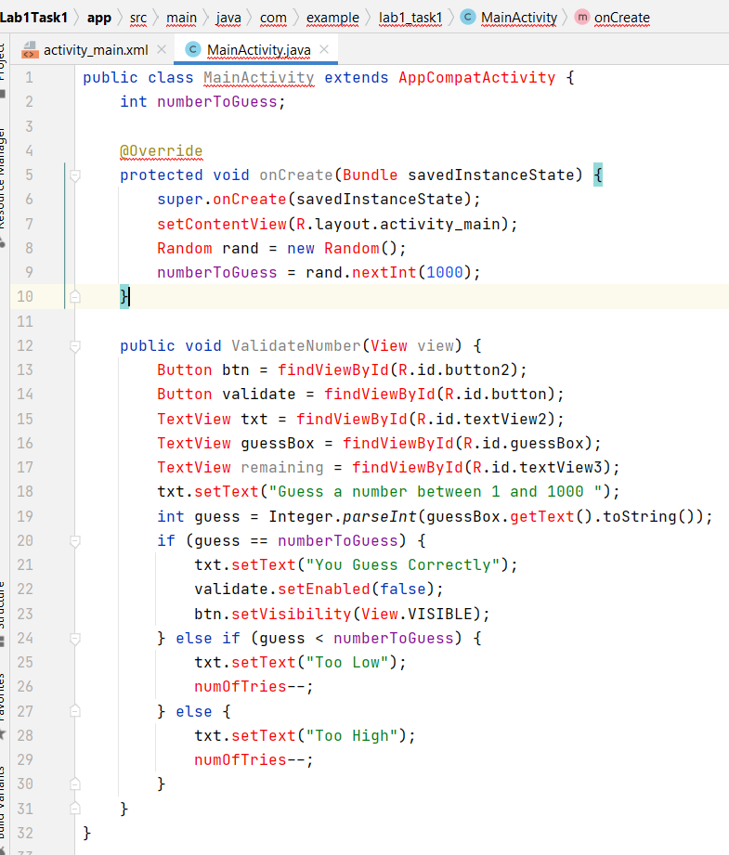

Output:

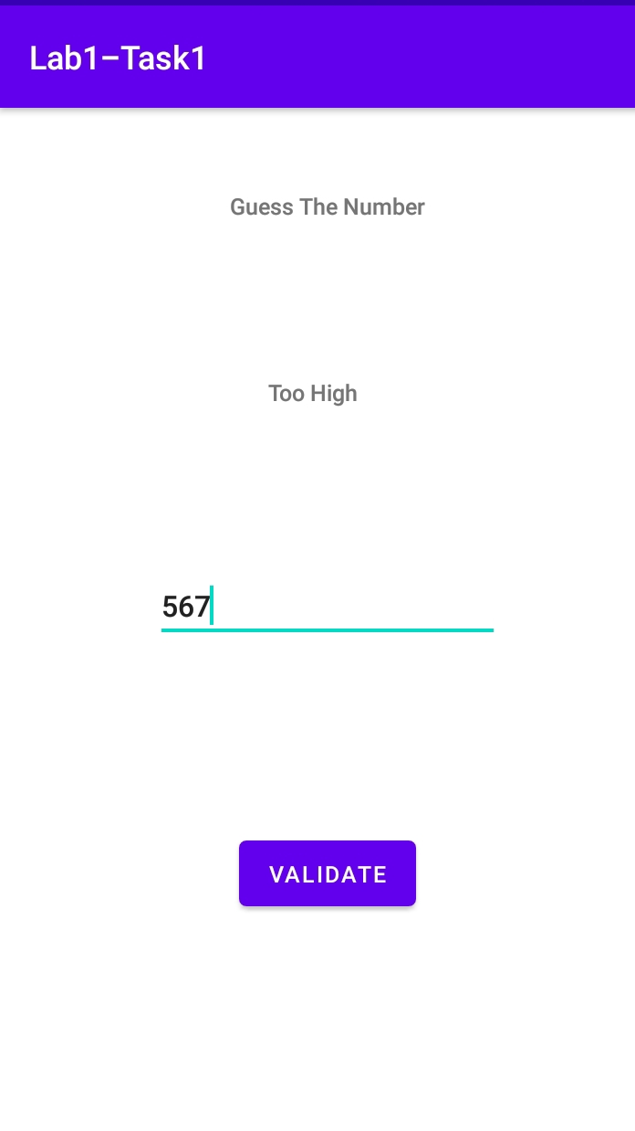

# Task-2:

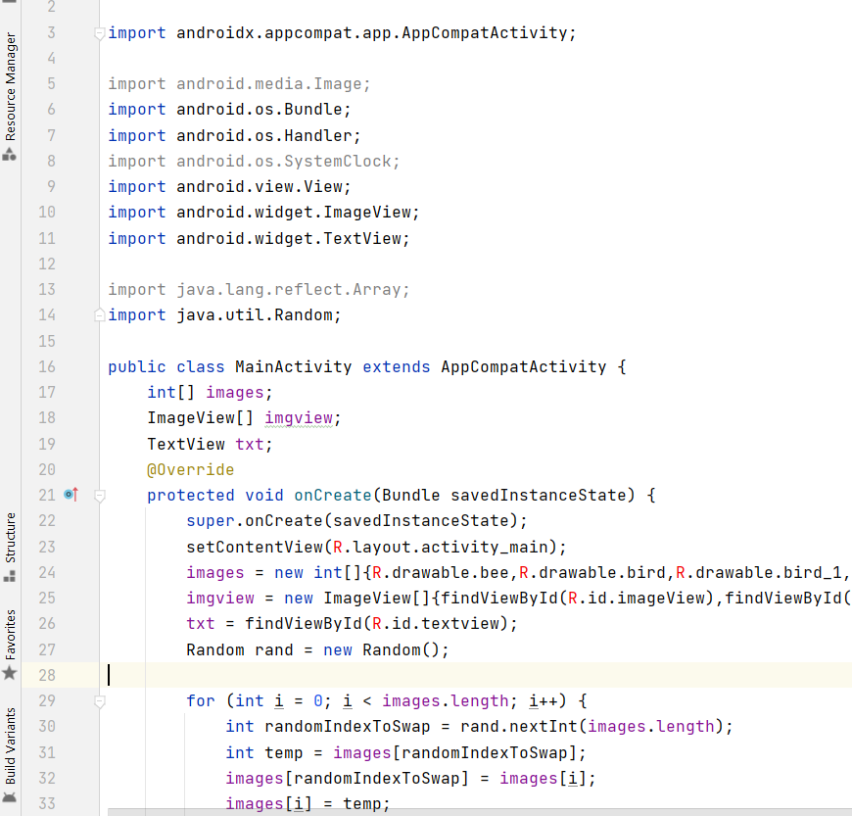

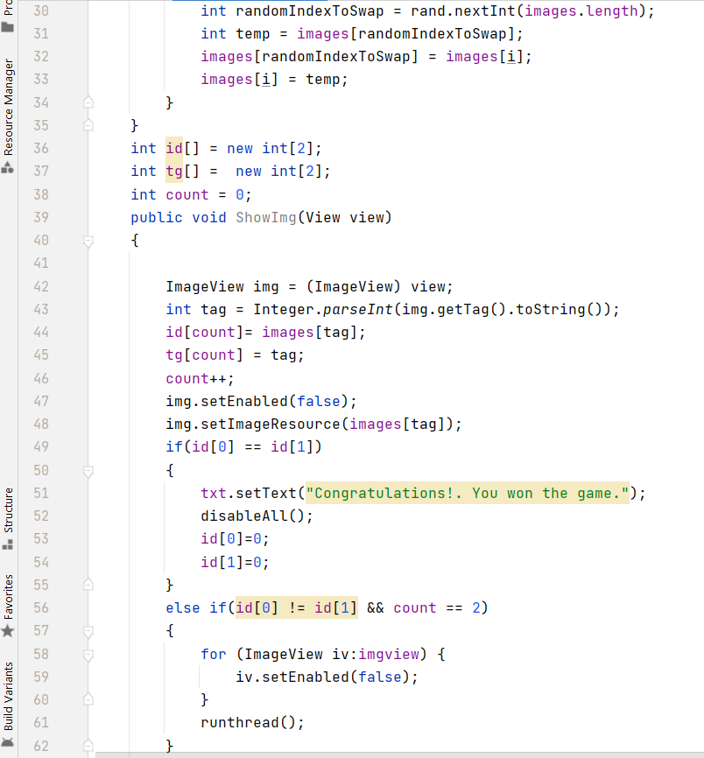

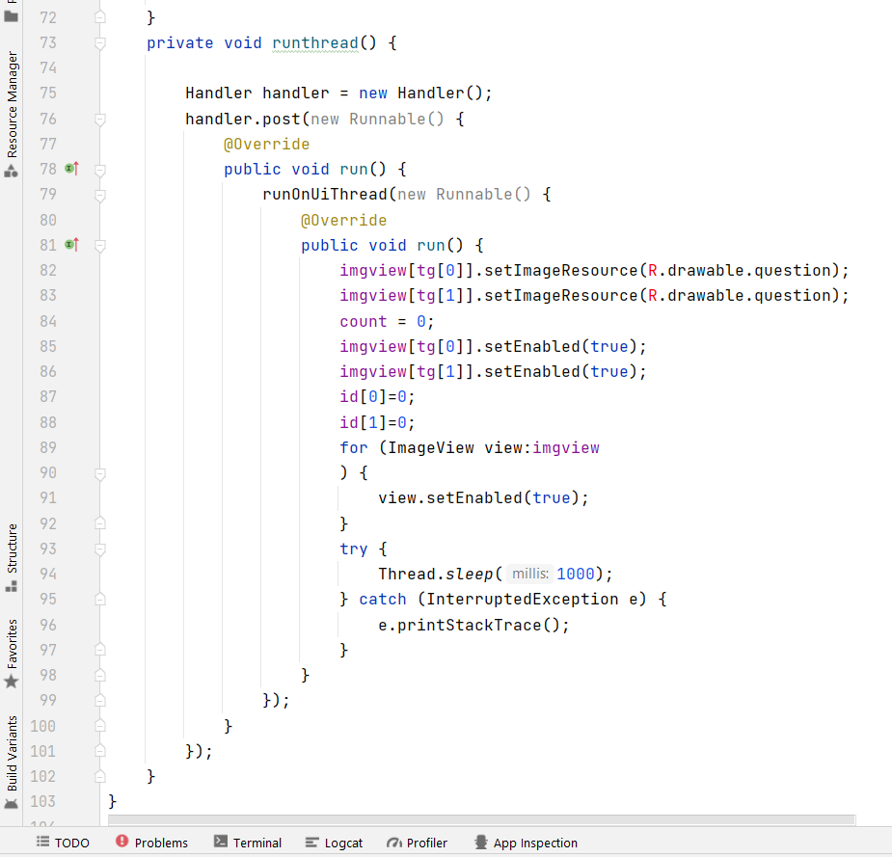

Output:

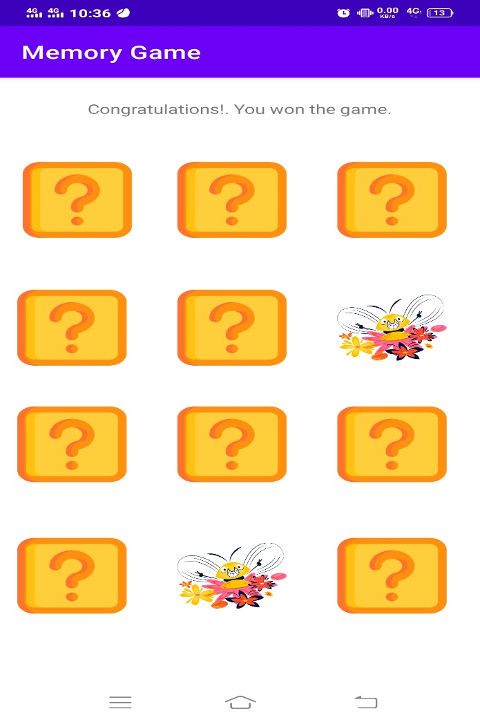

# Task-3

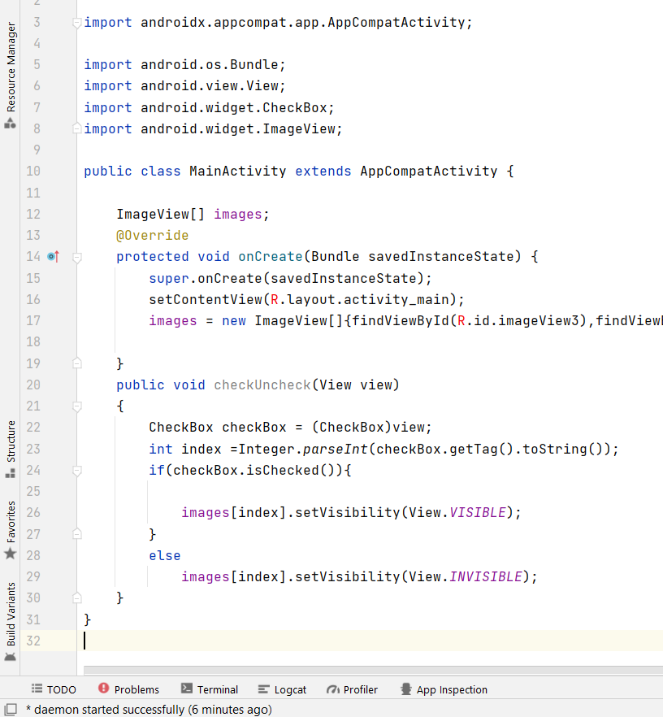

Output:

